Story of the digestive system

Below is the order that food passes through the digestive system. Match up the correct parts of the story from the separate sheet that helps explain what happens as food passes through each part.

Mouth
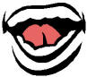

Oesophagus
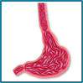

Stomach
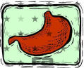

Small intestine
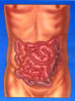

Large intestine
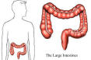

Rectum
